1. Component: ScanFolderLib

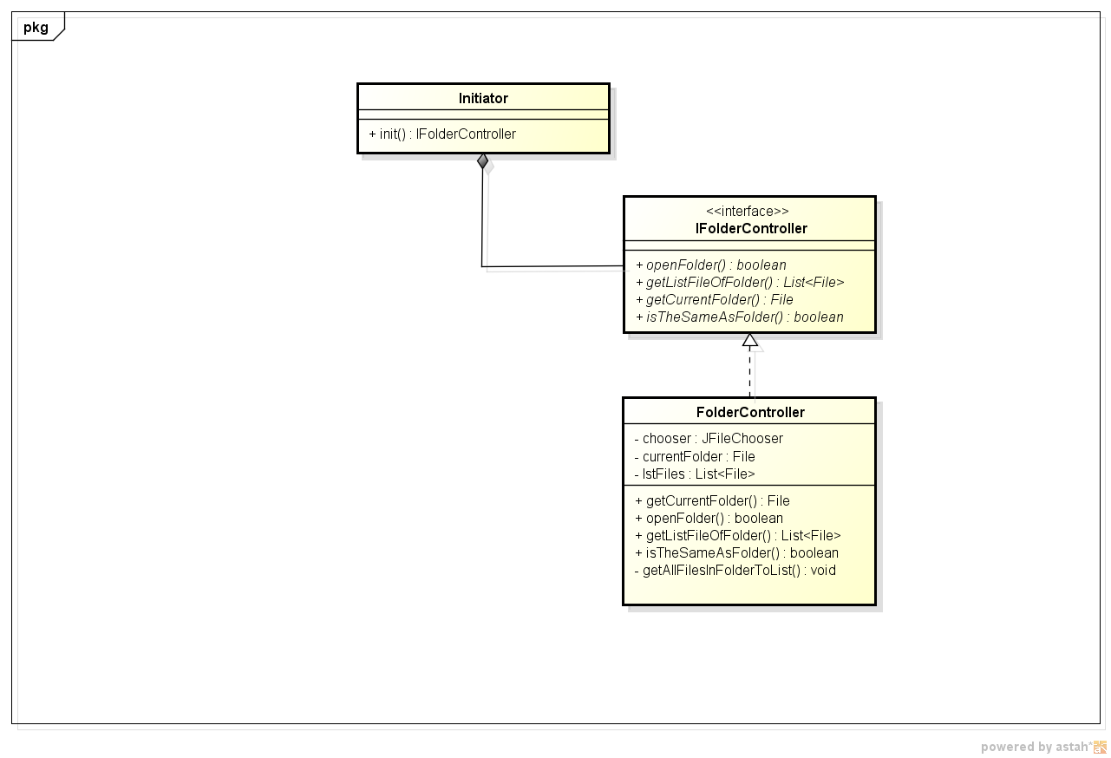

|  |  |  |  |
| --- | --- | --- | --- |
| **Initiator** | | | |
| **Attributes** | | | |
| Name | Type | Initialize | Description |
|  |  |  |  |
| **Methods** | | | |
| **Method Name** | init | Scope | public |
| Return | Return Type | Description | |
| A | IfolderController | * Create new instance Folder Controller | |
| Parameter | Type | Default Value | |

|  |  |  |  |
| --- | --- | --- | --- |
| **IFolderController** | | | |
| **Attributes** | | | |
| Name | Type | Initialize | Description |
|  |  |  |  |
| **Methods** | | | |
| **Method Name** | openFolder | Scope | public |
| Return | Return Type | Description | |
| A | Boolean | Set info of current folder | |
| Parameter | Type | Default Value | |
|  |  |  | |
| **Method Name** | getCurrentFolder | Scope | public |
| Return | Return Type | Description | |
| A | File | Get info of current Folder | |
| Parameter | Type | Default Value |  |
|  |  |  |  |
| **Method Name** | getListFileOfFolder | Scope | public |
| Return | Return Type | Description |  |
| A | List<File> | Get all file in folder |  |
| Parameter | Type | Default Value |  |
| folder | File |  |  |

|  |  |  |  |
| --- | --- | --- | --- |
| **FolderController** | | | |
| **Attributes** | | | |
| Name | Type | Initialize | Description |
| chooser | JFileChooser |  | Private |
| currentFolder | File |  | Private |
| lstFiles | List<File> |  | Private |
| **Methods** | | | |
| **Method Name** | getCurrentFolder | Scope | Public |
| Return | Return Type | Description | |
| A | File | Get current Folder Info | |
| Parameter | Type | Default Value |  |
| **Method Name** | openFolder | Scope | Public |
| Return | Return Type | Description | |
| A | boolean | Set current Folder Info | |
| Parameter | Type | Default Value |  |
| **Method Name** | getListFileOfFolder | Scope | Public |
| Return | Return Type | Description | |
| A | List<File> | Get List file in Folder | |
| Parameter | Type | Default Value |  |
| folder | File |  |  |
| **Method Name** | isTheSameAsFolder | Scope | Public |
| Return | Return Type | Description | |
| A | boolean | Check the same of folder | |
| Parameter | Type | Default Value |  |
| pathFolder | String |  |  |
| **Method Name** | getAllFilesInFolderToList | Scope | Private |
| Return | Return Type | Description | |
| N/A |  | Get all file in folder to list of folder | |
| Parameter | Type | Default Value |  |
| folder | File |  |  |

1. Component: CompareLib

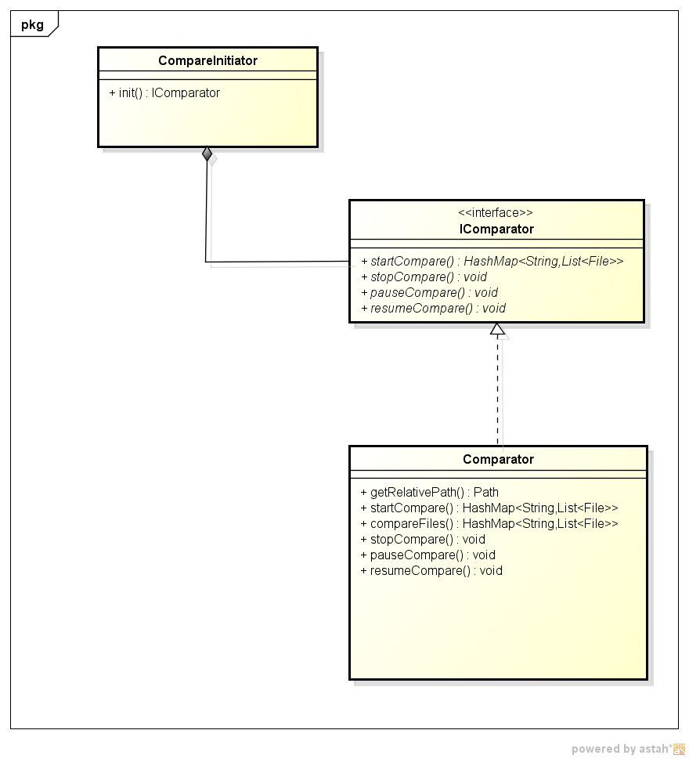

|  |  |  |  |
| --- | --- | --- | --- |
| **CompareInitiator** | | | |
| **Attributes** | | | |
| Name | Type | Initialize | Description |
|  |  |  |  |
| **Methods** | | | |
| **Method Name** | init | Scope | public |
| Return | Return Type | Description | |
| N/A | IComparator | Create new instance Comparator | |
| Parameter | Type | Default Value | |
|  |  |  | |
| **IComparator** | | | |
| **Attributes** | | | |
| Name | Type | Initialize | Description |
|  |  |  |  |
| **Methods** | | | |
| **Method Name** | startCompare | Scope | public |
| Return | Return Type | Description | |
| A | HashMap<String, List<File[]>> | Compare two folder | |
| Parameter | Type | Default Value | |
| dirMasterA | String |  | |
| dirMasterB | String |  | |
| fileList1 | List<File> |  | |
| fileList2 | List<File> |  | |
| **Methods** | | | |
| **Method Name** | stopCompare | Scope | public |
| Return | Return Type | Description | |
| N/A |  |  | |
| Parameter | Type | Default Value | |
|  |  |  | |
| **Methods** | | | |
| **Method Name** | pauseCompare | Scope | public |
| Return | Return Type | Description | |
| N/A |  |  | |
| Parameter | Type | Default Value | |
|  |  |  | |
| **Methods** | | | |
| **Method Name** | resumeCompare | Scope | public |
| Return | Return Type | Description | |
| N/A |  |  | |
| Parameter | Type | Default Value | |
|  |  |  | |

|  |  |  |  |
| --- | --- | --- | --- |
| **Comparator** | | | |
| **Attributes** | | | |
| Name | Type | Initialize | Description |
|  |  |  |  |
| **Methods** | | | |
| **Method Name** | getRelativePath | Scope | public |
| Return | Return Type | Description | |
| A | Path | Get Relative of file choosed. | |
| Parameter | Type | Default Value | |
| children | String |  | |
| master | String |  | |
| **Methods** | | | |
| **Method Name** | startCompare | Scope | public |
| Return | Return Type | Description | |
| A | HashMap<String, List<File[]>> | Get Relative of file choosed. | |
| Parameter | Type | Default Value | |
| children | String |  | |
| master | String |  | |
| **Methods** | | | |
| **Method Name** | compareFiles | Scope | private |
| Return | Return Type | Description | |
| A | HashMap<String, List<File[]>> | Compare two folder | |
| Parameter | Type | Default Value | |
| dirMaster | String |  | |
| listFile | String |  | |
| map | HashMap<String, File> |  | |
| order | Int |  | |
| **Methods** | | | |
| **Method Name** | stopCompare | Scope | public |
| Return | Return Type | Description | |
| N/A |  |  | |
| Parameter | Type | Default Value | |
|  |  |  | |
|  |  |  | |
| **Methods** | | | |
| **Method Name** | pauseCompare | Scope | public |
| Return | Return Type | Description | |
|  |  |  | |
| Parameter | Void | Default Value | |
|  |  |  | |
|  |  |  | |
| **Methods** | | | |
| **Method Name** | resumeCompare | Scope | public |
| Return | Return Type | Description | |
|  |  |  | |
| Parameter | Void | Default Value | |
|  |  |  | |
|  |  |  | |

1. Criterion1Lib

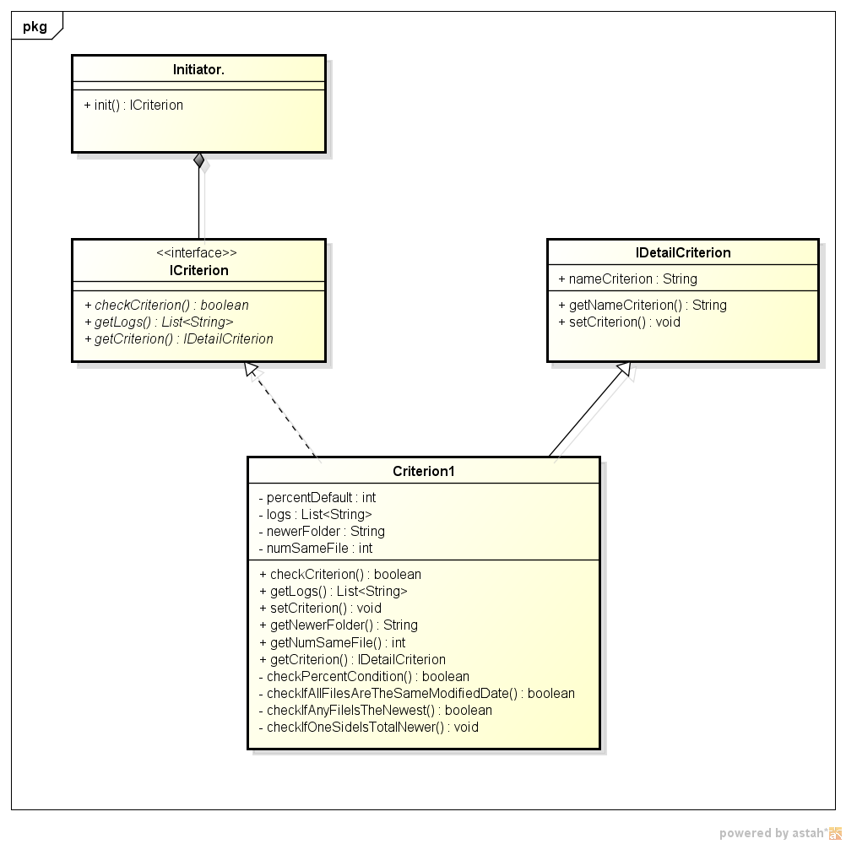

|  |  |  |  |
| --- | --- | --- | --- |
| **Initiator** | | | |
| **Attributes** | | | |
| Name | Type | Initialize | Description |
| N/A |  |  |  |
| **Methods** | | | |
| **Method Name** | init | Scope | public |
| Return | Return Type | Description | |
| A | ICriterion | Create new instance of ICriterion | |
| Parameter | Type | Default Value | |
|  |  |  | |

|  |  |  |  |  |
| --- | --- | --- | --- | --- |
| **ICriterion** | | | | |
| **Attributes** | | | | |
| Name | Type | | Initialize | Description |
| N/A |  | |  |  |
| **Methods** | | | | |
| **Method Name** | checkCriterion | | Scope | public |
| Return | Return Type | | Description | |
| A | boolean | | Check criterion of folder | |
| Parameter | Type | | Default Value | |
| lstFinalResul | HashMap<String, List<File[]>> | |  | |
| sizeMinFolder | int | |  | |
| **Methods** | | | | |
| **Method Name** | getLogs | Scope | | public |
| Return | Return Type | Description | | |
| A | List<String> |  | | |
| Parameter | Type | Default Value | | |
|  |  |  | | |
| **Methods** | | | | |
| **Method Name** | getCriterion | Scope | | public |
| Return | Return Type | Description | | |
| A/A |  |  | | |
| Parameter | Type | Default Value | | |
|  |  |  | | |

|  |  |  |  |
| --- | --- | --- | --- |
| **IDetailCriterion** | | | |
| **Attributes** | | | |
| Name | Type | Initialize | Description |
| nameCriterion | String |  |  |
| **Methods** | | | |
| **Method Name** | String | Scope | public |
| Return | Return Type | Description | |
| A | nameCriterion | Create new instance of Criterion1 | |
| Parameter | Type | Default Value | |
|  |  |  | |
| **Methods** | | | |
| **Method Name** | setCriterion | Scope | public |
| Return | Return Type | Description | |
| N/A |  |  | |
| Parameter | Type | Default Value | |
| criterion | int |  | |

|  |  |  |  |
| --- | --- | --- | --- |
| **Criterion1** | | | |
| **Attributes** | | | |
| Name | Type | Initialize | Description |
| percentDefault | Int |  |  |
| logs | List<String> |  |  |
| newerFolder | String |  |  |
| numSameFile | int |  |  |
| **Methods** | | | |
| **Method Name** | Criterion1 | Scope | public |
| Return | Return Type | Description | |
| N/A |  |  | |
| Parameter | Type | Default Value | |
|  |  |  | |
| **Methods** | | | |
| **Method Name** | checkCriterion | Scope | public |
| Return | Return Type | Description | |
| A | Bollean |  | |
| Parameter | Type | Default Value | |
| lstFinalResul | HashMap<String, List<File[]>> |  | |
| sizeMinFolder | int |  | |
| **Methods** | | | |
| **Method Name** | getLogs | Scope | public |
| Return | Return Type | Description | |
| A | List<String> |  | |
| Parameter | Type | Default Value | |
|  |  |  | |
| **Methods** | | | |
| **Method Name** | setCriterion | Scope | public |
| Return | Return Type | Description | |
| A | int |  | |
| Parameter | Type | Default Value | |
|  |  |  | |
| **Methods** | | | |
| **Method Name** | getNewerFolder | Scope | public |
| Return | Return Type | Description | |
| A | String |  | |
| Parameter | Type | Default Value | |
|  |  |  | |
| **Methods** | | | |
| **Method Name** | getNumSameFile | Scope | public |
| Return | Return Type | Description | |
| A | int |  | |
| Parameter | Type | Default Value | |
|  |  |  | |
| **Methods** | | | |
| **Method Name** | getCriterion | Scope | public |
| Return | Return Type | Description | |
| A | IDetailCriterion |  | |
| Parameter | Type | Default Value | |
|  | s |  | |
| **Methods** | | | |
| **Method Name** | checkPercentCondition | Scope | public |
| Return | Return Type | Description | |
| A | Boolean |  | |
| Parameter | Type | Default Value | |
| lstFinalResul | HashMap<String, List<File[]>> |  | |
| sizeMinFolder | int |  | |
| **Methods** | | | |
| **Method Name** | checkIfAllFilesAreTheSameModifiedDate | Scope | public |
| Return | Return Type | Description | |
| A | Boolean |  | |
| Parameter | Type | Default Value | |
| lstFinalResuls | HashMap<String, List<File[]>> |  | |
|  |  |  | |
| **Methods** | | | |
| **Method Name** | checkIfAnyFileIsTheNewest | Scope | public |
| Return | Return Type | Description | |
| A | Boolean |  | |
| Parameter | Type | Default Value | |
| lstFinalResul | HashMassp<String, List<File[]>> |  | |
|  |  |  | |
| **Methods** | | | |
| **Method Name** | checkIfOneSideIsTotalNewer | Scope | public |
| Return | Return Type | Description | |
| A | Boolean |  | |
| Parameter | Type | Default Value | |
| lstFinalResul | HashMap<String, List<File[]>> |  | |
|  |  |  | |